Exercise 1: **BROWSER**

The hypotheses:

Adding trust-inducing copy on the email, phone and opt-in fields at checkout will lead to an increase in transactions.

Test run dates: 10/18/19- 10/31/19

Device : Desktop, Mobile

I am further exploring the Users(New and existing) and the Returning Users to see if the test results in increase in transactions or conversions.

Steps:

1. View- Test View
2. Select a date range. pre-event Oct 4th to Oct 17th :post-event- Oct 18th – Oct 31st
3. Pick segment : Returning Users

For each combination of Dimensions and Metrics, I am doing a descriptive analysis and also applying Linear Regression to the test period data to determine the statistical significance.

A linear regression is say like :

Y ~ aX1 + bX2 + cX3

The concept of Linear Regression is determining the proportion of variation of the dependent variable (Y), due to independent variable(predictors) X1 or X2 or X3.

P-values and coefficients(a, b or c) in regression analysis work together to tell which relationships in the model are statistically significant and the nature of those relationships.

The coefficients describe the mathematical relationship between each independent variable and the dependent variable. Each regression coefficient is independent of all the other predictors. If ‘a’ is positive, then for every one unit increase in X1, Y increase by ‘a’. On the other hand, if ‘a’ is negative, for every one unit increase in ‘a’, Y decreases by ‘a’ unit.

The null hypothesis of the model is that predictors are insignificant. If P value is <0.05 it means that there is very less probability that the predictor is insignificant, so we reject the Null.

In the following analysis, I am considering P-values just to determine the statistical significance for the predictors **in the test period**.

**Conversions: eCommerce**

**#1. Users. Dimensions**: Browser, Gender **Metrics**: Revenue

**Returning Users. Dimensions**: Browser, Gender **Metrics**: Revenue

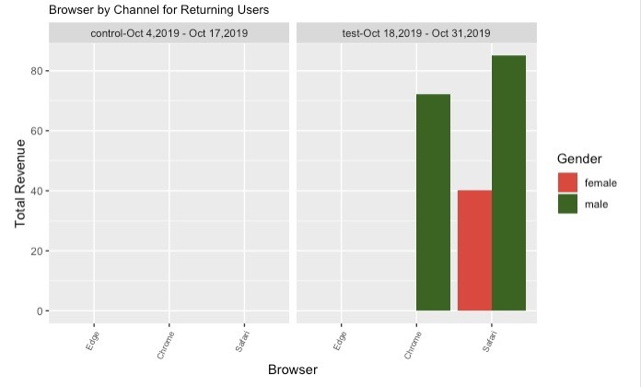

In the test period, for the Users, Browser Safari and Gender-Male are significant in Revenue variation. For the Returning Users, Browser or Gender don’t have any statistical significance on variation in Revenue.

#2. **Users. Dimensions:** Browser, Device **Metrics:** Revenue

**Figure A**

**Returning Users. Dimensions:** Browser, Device **Metrics:** Revenue

In the test period, for both New and Returning Users, Browser Chrome and Safari has statistical significance in Revenue variation when regressed with Device.

**#3. Users. Dimensions:** Browser, Age **Metrics:** Revenue

**Returning Users. Dimensions:** Browser, Age **Metrics:** Revenue

In the test period, for both Users and Returning Users, Browser has no significance on Revenue variation when regressed with Age in the dataset.

**#4. Users. Dimensions:** Browser, Hour **Metrics:** Revenue

**Returning Users. Dimensions:** Browser, Hour **Metrics:** Revenue

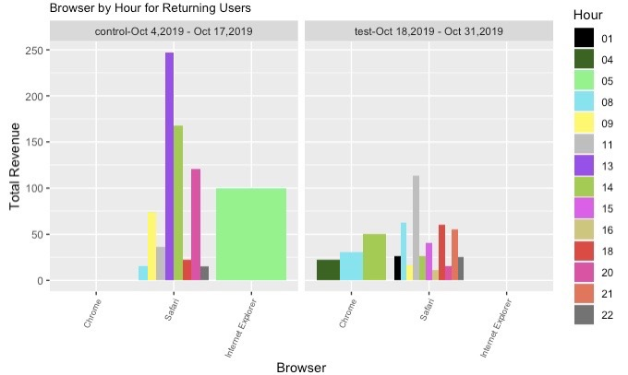

In the test period, Browser has no significance for both Users and Returning Users, while Hour 08 is significant for Users in Revenue variation.

**#5. Users. Dimensions:** Browser, Country **Metrics:** Revenue

**Returning Users. Dimensions:** Browser, Country **Metrics:** Revenue

In the test period, Browser has no significance, Country United Kingdom for Users and Belgium for Returning Users are significant in Revenue variation.

**#6. Users. Dimensions:** Browser, City **Metrics:** Revenue

**Returning Users. Dimensions:** Browser, City **Metrics:** Revenue

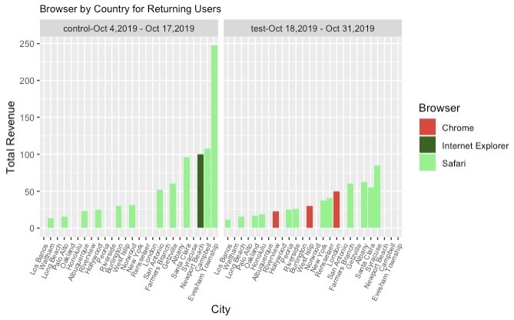

In the test period, Browser is not significant, however Cities as listed above are significant for Users and Returning Users in Revenue variation.

**#7. Users.**  **Dimensions:** Browser, Channel **Metrics:** Revenue

**Returning Users.**  **Dimensions:** Browser, Channel **Metrics:** Revenue

In this dataset for test period, Users and Transactions are significant in Revenue variation.

**#8. Goal1: Users. Dimensions:** Browser **Metrics:** Purchases completed

**Returning Users. Dimensions:** Browser **Metrics:** Purchases Completed

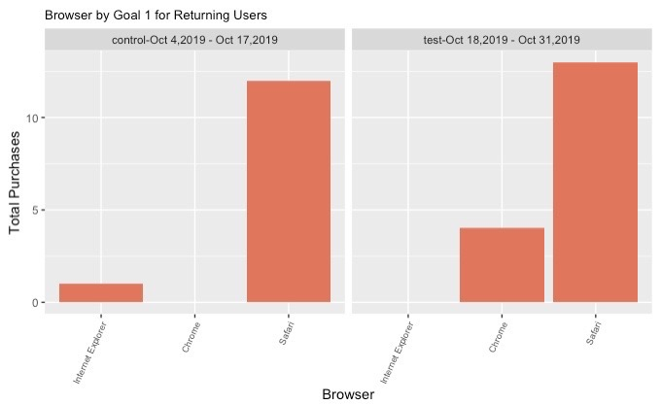

**#9. Goal 2: Users. Dimensions:** Browser **Metrics:** Engaged Users

**Returning Users. Dimensions:** Browser **Metrics:** Engaged Users

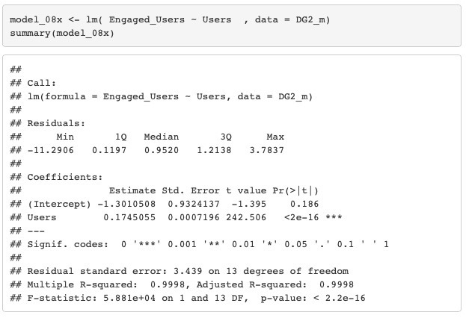

**#10. Goal 3: Users. Dimensions:** Browser **Metrics:** Total Registrations

**Returning Users. Dimensions:** Browser **Metrics:** Registrations Completed

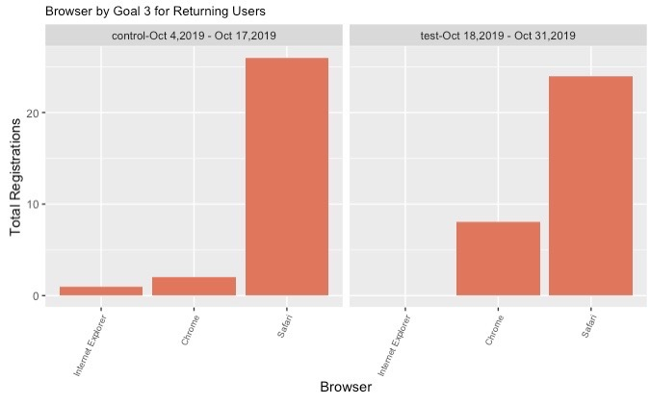

**#11. Goal 4: Users. Dimensions:** Browser **Metrics:** Entered Checkout

**Returning Users. Dimensions:** Browser **Metrics:** Registrations Completed

**#12. Goal 5: Users. Dimensions:** Browser **Metrics:** Smart Goals

**Returning Users. Dimensions:** Browser **Metrics:** Smart Goals

In the test period, Goal 1- Purchases Completed, Goal 2- Engaged Users, Goal 3 – Total Registrations, Goal 4 – Entered Checkout and Goal 5- Smart Goals have Users as statistically significant in Revenue variation.

**#13. Users.**  **Dimensions:** Browser, Days to Transaction **Metrics:** Revenue

**Returning Users.**  **Dimensions:** Browser, Days to Transaction **Metrics:** Revenue

In the test period, Days to transaction is not significant for Revenue variation for both Users and Returning Users.

**INFERENCE:**

Browser’s Chrome and Safari are positively significant (Fig. A) when regressed with Device in variations of Revenue for Users. In various datasets when Browser is regressed with other dimensions as Age, Country, City, Gender, Channel, Browser or Days to Transaction, it is not significant in variations in Revenue.